**DAILY ONLINE ACTIVITIES SUMMARY**

|  |  |  |  |  |  |  |  |  |
| --- | --- | --- | --- | --- | --- | --- | --- | --- |
| **Date:** | **18/06/2020** | | | | | **Name:** | **NIKHIL KUMAR** | |
| **Sem & Sec** | **4thSEM. & ‘B’ SEC.** | | | | | **USN:** | **4AL19CS400** | |
| **Online Test Summary** | | | | | | | | |
| **Subject 1** | | **NIL** | | | | | | |
| **Max. Marks** | | **NIL** | | **Score** | | | **NIL** | |
| **Certification Course Summary** | | | | | | | | |
| **Course** | **Introduction to ethical hacking** | | | | | | | |
| **Certificate Provider** | | | **Greatlearning**  **Academy** | | **Duration** | | | **4.0 Hrs.** |
| **Coding Challenges** | | | | | | | | |
| **Problem Statement1 : Write a c program to generate first N Magic Numbers.** | | | | | | | | |
| **Status: Executed** | | | | | | | | |
| **Uploaded the report in Github** | | | | | **Yes** | | | |
| **If yes Repository name** | | | | | 1. <https://github.com/Nikhil401/c-codding/blob/master/MagicNumber.cpp> | | | |
| **Uploaded the report in slack** | | | | | **Yes** | | | |

**Certification Course Summary: Today I have learnt something about Ethical hacking on mobile platform-Demonstration under ethical hacking and the snapshot is given below:**

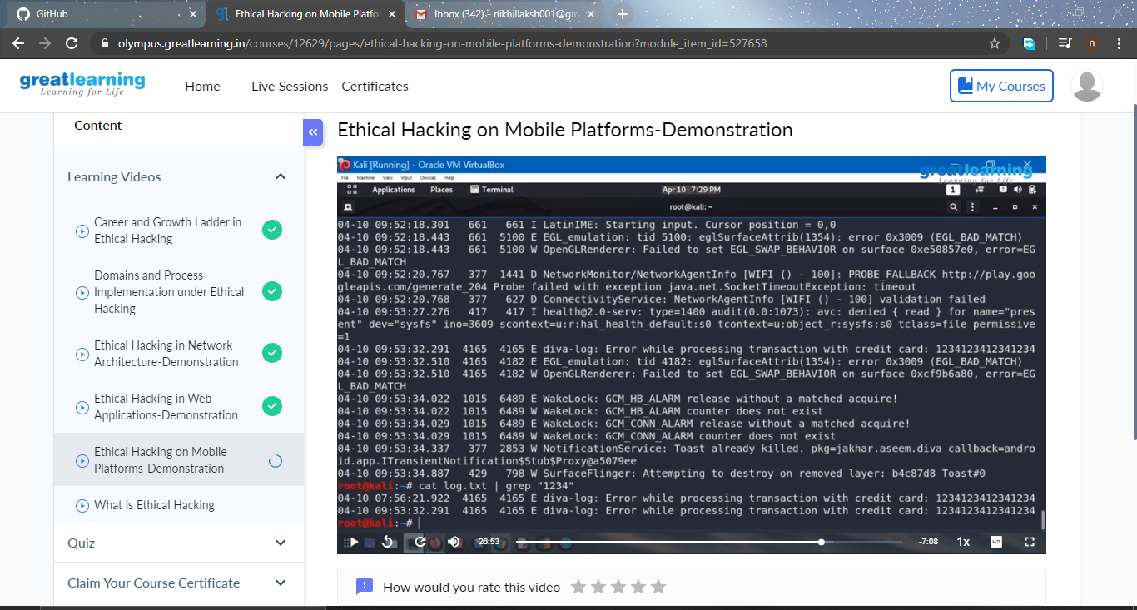**Online Coding Summary: Today I received a program from prof . venkatesh and CSE Dept. The program is mentioned above(pg.01). to my GitHub repository link and I’ve shared the snapshot below.** 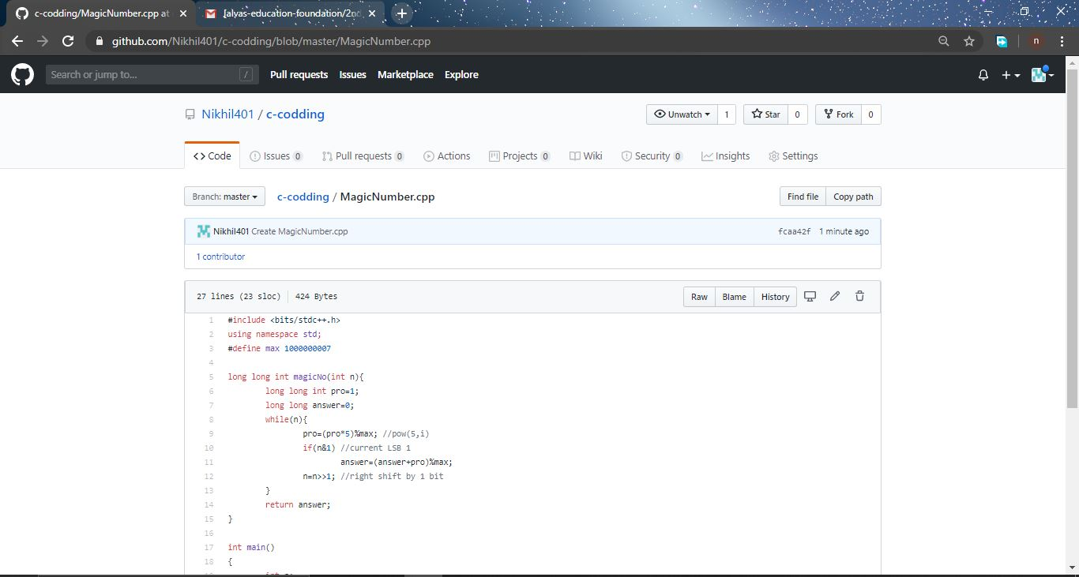 **Thank you.**